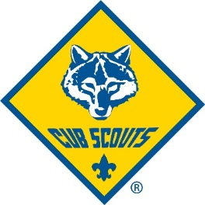
Cal-Mum Cub Scouts
Pack 4027

February 2015 Newsletter

Pinewood Derby
On Friday February 20th we will be setting up the track for the Pinewood Derby. We are looking for 10 volunteers to meet at the elementary school auditorium at 6 pm to set up the track and decorate for the derby. Once we have the track setup there will be time to test out the boys cars. We are also looking for anyone interested in baking cookies so we can provide the boys snacks at the event. If you are interested please send an email to calmumcubs@gmail.com to let us know who will be able to help!
On Saturday February 21st will be the Pinewood Derby Race. Please arrive at 1 pm for car check in and weighing. We will have limited time for last minute changes so please arrive on time. We will need volunteers for the following: Registration 2 people, Pit Crew 2 people, and Time Keepers 3 people. There will be an informational meeting on February 9th at 7 pm in the cub room for anyone who can help out. Again email calmumcubs@gmail.com if you can help out.

Blue Cross Arena Fundraiser

Our next fundraising event will be on February 27th at the Blue Cross Arena concession stand for an Ameks Hockey game. This is a great opportunity to earn money for our pack without having to sell to our family, friends, and neighbors! It is also really a lot of fun and not very hard work at all. If you would like to join us please email calmumcubs@gmail.com.

.

Upcoming Events
Volunteer meeting 2/9 7:00 pm
Pinewood Derby Set-up 2/20 6:00pm
Pinewood Derby 2/21 1:00pm
Blue Cross Arena Fundraiser 2/27 5:15pm

Looking Forward

March-Crossover
April-Blue and Gold Banquet

Notes

If anyone has any ideas for Go-See-It’s we can do as a pack, please pass the info along. We want to get the Cubs out and having fun as much as possible and would like input on things you think they may enjoy doing. For the Blue and Gold Banquet each Den will be asked to perform a skit and song for the pack. Leaders, if you need any help or ideas please let us know at calmumcubs@gmail.com.

Any questions or concerns please contact the committee:
calmumcubs@gmail.com

